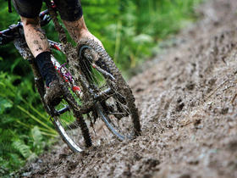
Are there any Mountain Bikers in ColGlen????
Russell would like to hear from you ….
Exciting times are ahead as the Development Trust buys Stronafian Forest. We are investigating the possibility of developing mountain bike trails in the forest and want to hear from you. Please get in touch if:
You know of places where you can go mountain biking in Cowal at the moment.
Your thoughts on what would make a Stronafian Forest a really great mountain biking venue.
If you would be interested in being involved in researching and planning the project.
You know of any mountain bikers who might not have seen this notice so I can track them down!
Contact Russell on 01369 820344 or 01700 841358 or russell.p.gill@googlemail.com
Alternatively pop in to say hello at Glendaruel Village hall

Supported by Cruach Mhor Windfarm Trust

