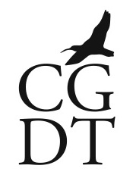
Calling all Interested Parties!

Are you involved in the tourist industry in Colintraive and Glandaruel?
Russell, working for the CGDT for two months on a government funded placement, wants to hear from you!
I’m looking to organise a focus group of anyone whose business interests are related to tourism. The group will try to collate your opinions and the day-to-day feedback you get from visitors to help the tourist industry in Colintraive and Glendaruel identify what can be done to improve and expand the facilities and attractions for visitors in a way that is sensitive to local concerns.
The results of the focus group will be invaluable in informing the long-term goals of the Development Trust as it progresses with present and future projects.
The meeting will be held at 7pm on Wednesday the 14th of September at Glendaruel Village Hall. If you intend to attend please contact me at russell.p.gill@googlemail.com or on 01369 820344. I hope as many of you can make it as possible. If you are unable to make this date but have ideas you want to share with the group please let me know and we’ll arrange an alternative time to meet up and have a chat.
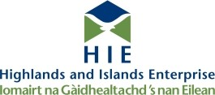

Supported by Cruach Mhor Windfarm Trust

