Stargazers……… Is there anyone out there???
Russell would like to hear from you……..
One of the ideas that has been proposed for Stronafian Forest is its development as a site for stargazing. The Development Trust are investigating this and want to find out more from the amateur astronomers of Colintraive and Glendaruel (we reckon there are at least 2 of you out there). We’d like to know:
Is there much/any light pollution?
How often do we have clear enough nights?
Where are the best places see the stars?
Would you be interested in helping us run a stargazing event in the forest?
Contact Russell on 01369 820344 or 01700 841358 or russell.p.gill@googlemail.com
Alternatively pop in to say hello at Glendaruel Village hall

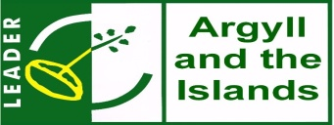

Supported by Cruach Mhor Windfarm Trust

